Firm valuation model - The cost of capital approach

The goal of this approach is to obtain the value of a firm today by discounting the free cash flow to the firm (FCFF) at the weighted average cost of capital (WACC), so it values the firm rather than the equity. This model suggests two different periods of growth: one of high growth and the other one, called steady-state, with a lower growth rate that the firm could maintain for a long period. One of the biggest advantages of this approach is that it captures the tax benefit of borrowing and the bankruptcy cost, and another one is that cash flow relating to debt does not have to be considered explicitly. The only pieces of information required are debt ratios and interest rate to estimate the cost of capital. The formula used to compute the value of a firm in this one:

Value of firm = $\sum{\frac{{FCFF}_{n}}{{(1+WACC)}^{n}}}+\frac{\frac{{FCFF}_{t}}{WACC -g_{t}}}{{1+{WACC}_{t}}^{t}}$

For a good explanation of the obtained values, hereafter there are all the assumption made during the computation:

* Since we have used a different way to compute FCFF and FCFE, I've must modified a little Damodaran's model. I'm going to consider, in addition to tax in EBIT, also the tax shield generated by financial items and changes in provision, employee benefit, tax asset and other minor to forecast consistently every value
* As we’ve seen previously, we computed WACC in three different approaches and I chose the third one for my valuation because we used a regression levered beta near to one and an average cost of debt of 2,18% (higher than others cost of debt used). Also, I used a different WACC (computed with beta equal to one) as a terminal cost of capital to obtain the terminal value at the end of the high growth period. So, i used a WACC for high growth period = to 4,70% (cost of equity = 7,08%) and another WACC for the steady-state = to 5,87% (cost of equity = 10,47%)
* An expected growth rate for EBIT = 8,26%, computed by dividing ROIC obtained in 2019 for the Reinvestment Rate = 115,98% (average of historical period). This growth rate is higher than that one stated by the management in the last strategic plan, maybe due to fact to make the expectation lower with the intention of beating them.
* For the growth rate in the steady-state, I wanted to use a fundamental growth rate extracted by Damodaran's dataset, which results equal to 7,68%, it’s a European average of growth rate for the utility sector. This value could seem really high to sustain for a long period of time, but I think, based on what management declared, that A2A might sustain it; first of all, because this company is green-oriented so it’s aiming to sustainability in term of production of energy but also with innovative projects like “Smart City”.

To forecast all items needed I've made some assumption about each one:

* Revenues: to forecast them first I've multiplied the last value available for the last recorded growth rate, and I assumed it constant for all the forecast period.
* EBIT: I considered EBIT always net of taxes (with constant tax rate = 27,9%) and to forecast future value I've computed a growth rate using the last ROIC available and an average of reinvestment rates.
* CAPEX: assuming it as a percentage of Revenues, so I've computed an average between percentages in historical data, and use it, constant, to forecast values in future period
* D&A: assuming it as a percentage of CAPEX, and to forecast its values I used the same methodology for CAPEX
* Changes in Provision: assuming a constant positive changes because their are unpredictable.
* Changes in Employees Benefit: being this asset not too volatile I'm going to use as forecast values the same value given by the average of changes
* Changes in TAX asset: I decide to take the last value of that asset constant for my forecast
* Other minor: as previous items I computed an average of changes during years and use it to forecast values for the future period
* Changes in NWC: I've assumed that they are a percentage of Revenues, after that I've made an average, and i used this value for each year in the forecast period

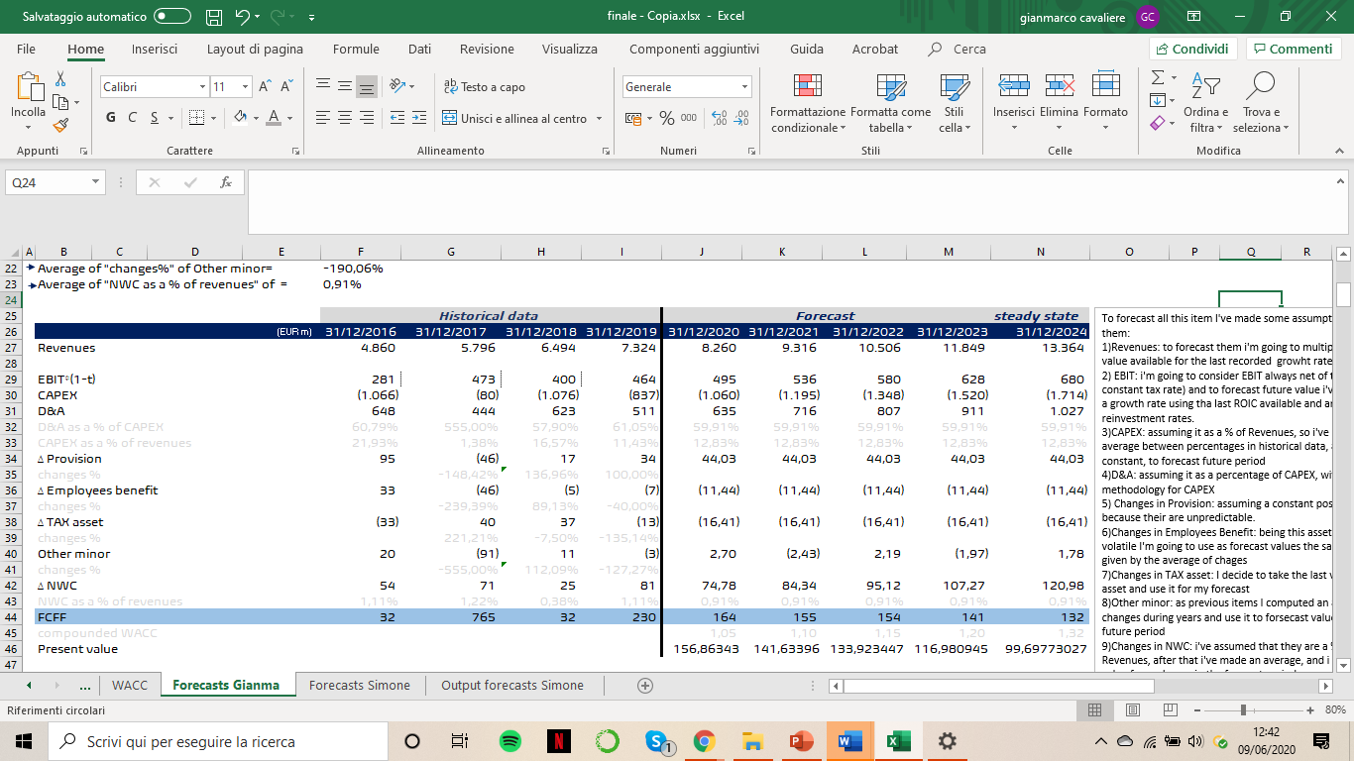

To obtain the value of EPS, as we can see below, first of all i computed the terminal value taking the last EBIT (steady-state) and multiplying it for stable growth rate, tax rate and reinvestment rate. After i divided the value obtained by the difference between stable WACC and stable growth rate. To get the discounted value i simply discounted it at the stable WACC. Once I've obtained this value, i summed up that one with the forecasted and discounted free cash flows. This sum is the terminal value, also called the enterprise value. From it to equity value we have to add “cash and marketable securities”, “value of minority holdings” and “value of inutilized asets”, and substact out non-equity claims on the company.

Doing that, I arrived to the “value of equity in common stock” and dividing it for the outstanding shares (3109,18) i obtained the value of a single share.

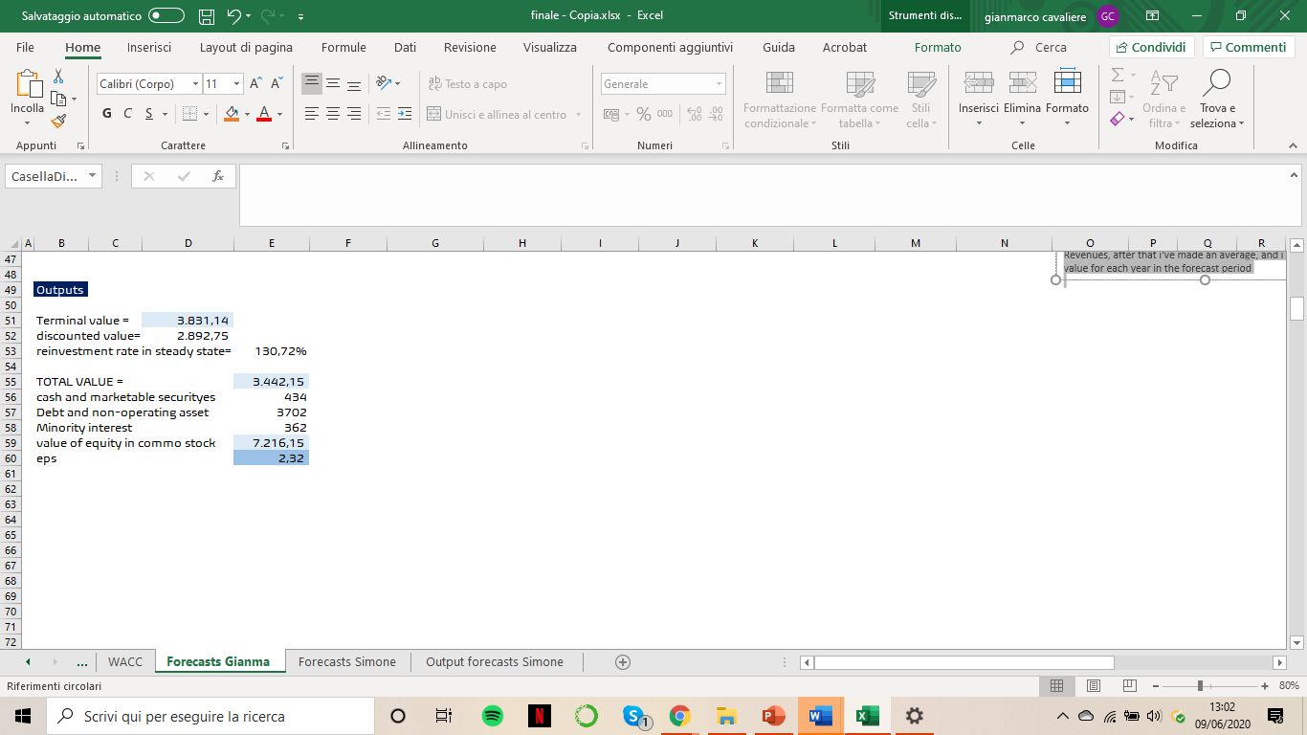

Nowadays the stock is trading at about 1,35 euros per share, making it heavily undervalued. But a clarification is worth to be done: this is the actual value of the company, which recorded an huge decrease (more or less 60 %) due to COVID-19 crisis, that it had influenced the greatest majority, if not every, sector.

Before this period, the share was trading at about 1,8 euros per share and A2A stock price was characterized by a constant positive trend from 2012 up to now. So If we are assuming a stock price pre-crisis, the difference between the value obtained from the approach used and the traded price is lower than the difference with the actual value, making the value obtained more acceptable.